Dimension Funding, LLC
David Budman, Managing Director

1439 W. Chapman Avenue, Suite 353
Orange, CA 92868
Ph: (800) 755-0585 x204

dbudman@dimensionfunding.com
Commercial Finance Application
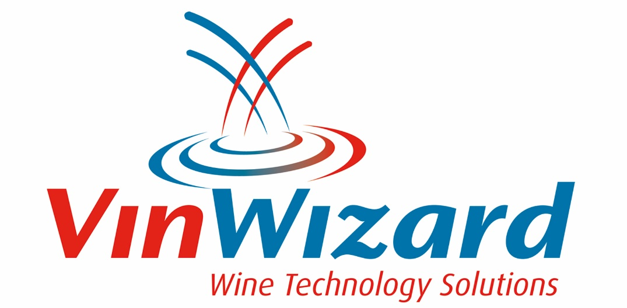

LEGAL COMPANY NAME |  |  |  |  |  |  |  | DATE ESTABLISHED (CURRENT OWNERSHIP) |  |  |  | Web Page Address
PRIMARY BUSINESS ADDRESS |  |  |  |  |  |  |  |  | CITY |  |  |  | STATE |  | ZIP CODE
DBA |  |  |  |  |  |  | Email Address |  |  |  | TELEPHONE |  |  | FAX
BUSINESS STRUCTURE Check Box or specify |  |  |  |  |  | NATURE OF BUSINESS |  |  |  |  |  |  |  | STATE OF INCORPORATION
Proprietorship | Partnership |  | Corporation | LLC | Other
 |  |  |  |  |  | FEDERAL TAX NO.
Specify other: |  | _________________

VENDOR NAME | ADDRESS | CITY |  |  |  |  | STATE |  |  |  |  |  | ZIP
Wine Technology Inc. dba VinWizard | 474 Walten Way | Windsor |  |  |  |  | CA |  |  |  |  |  | 95492

CONTACT NAME & PHONE NUMBER
Kelly Graves – 720.284.2059
EQUIPMENT DESCRIPTION |  |  | NEW |  |  |  |  | USED |  |  |  | TERM REQUESTED
Winery production automation system |  |  |  | X |  |  |  |  |  |  |  | 60 Months
INSTALLATION LOCATION (IF DIFFERENT FROM LEGAL ADDRESS ABOVE) |  |  |  |  | TOTAL INVOICE WITHOUT TAX

Authorization to Obtain Consumer Credit Report
By signing this application, the company signatory or Corporate Officer provides written instruction to Dimension Funding, LLC or its designee (and any assignee or potential assignee thereof) authorizing review of the business credit profile from a national credit bureau. Such authorization shall extend to obtaining a credit profile in considering the application of the credit applicant and subsequently for the purposes of update, renewal or extension of such credit and for reviewing or collecting the resulting account. A photo static or facsimile copy of this authorization shall be valid as the original.

Signature: X |  |  |  |  | DATE
Name (please print): |  |  | TITLE

